Resource order form – Health professionals

Download our free resources online, at breastscreen.org.au/resources

If you would like to order printed resources for your workplace, please fill out your details below and email this form to communications@breastscreen.org.au
Please note: Order maximum of 25 copies per resource applies.

Your details
Name
Clinic name
Address Post code
Email

Title |  | Qty | Title |  | Qty
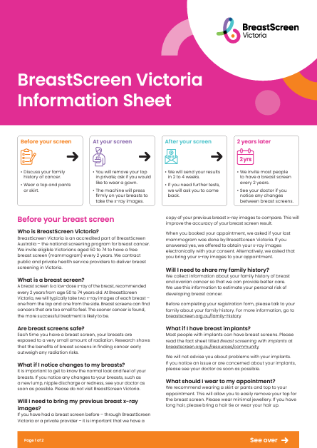 | BreastScreen Victoria Information Sheet  (A4 fact sheet) |  | 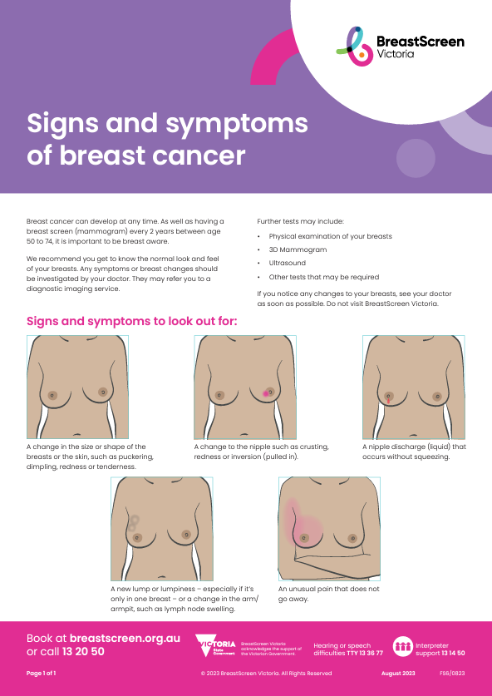 | Signs and symptoms of breast cancer  (A4 fact sheet)
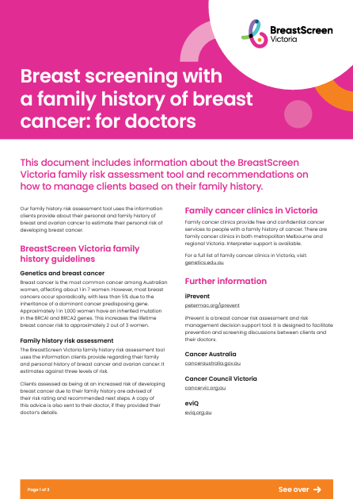 | Breast screening with a family history of breast cancer: information for doctors  (A4 fact sheet) |  | 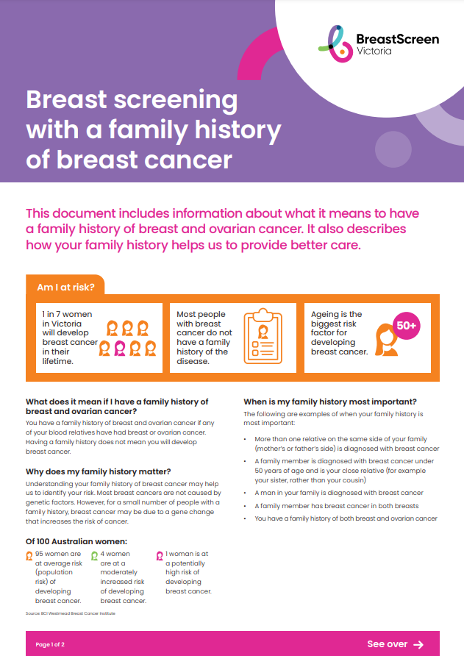 | Breast screening with a family history of breast cancer  (A4 fact sheet)
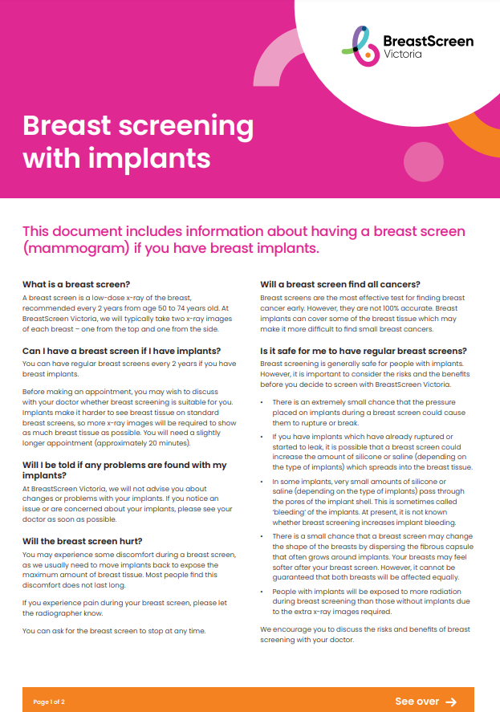 | Breast screening with implants  (A4 fact sheet) |  | 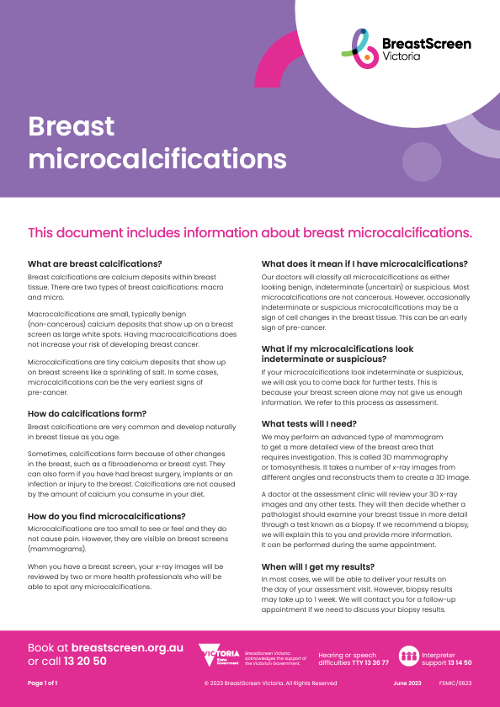 | Breast microcalcifications  (A4 fact sheet)

Title |  | Qty | Title |  | Qty
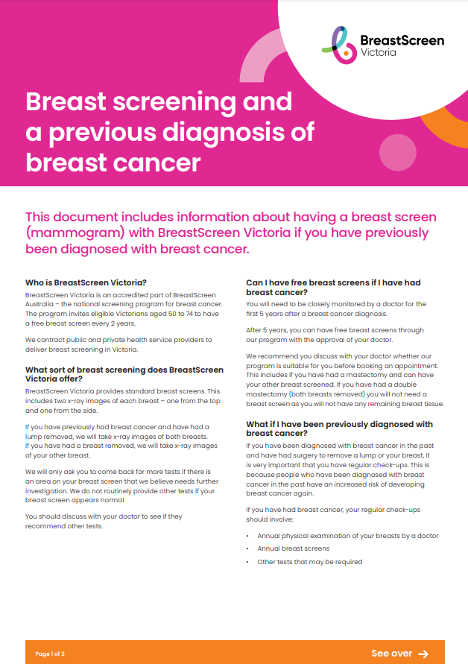 | Breast screening and a previous diagnosis of breast cancer  (A4 fact sheet) |  | 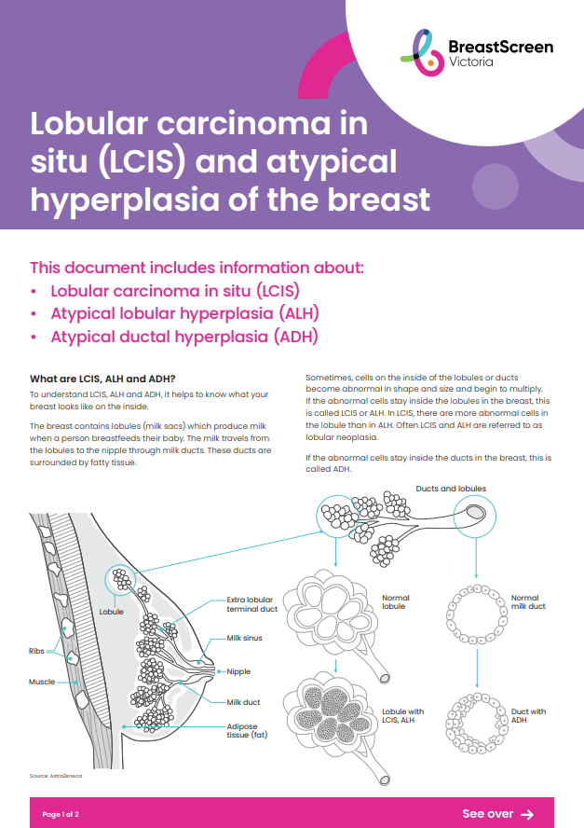 | Lobular carcinoma in situ (LCIS) and atypical hyperplasia of the breast  (A4 fact sheet)
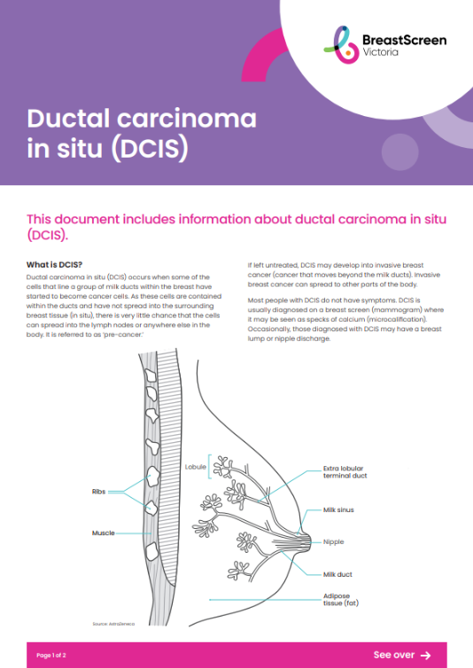 | Ductal carcinoma in situ (DCIS)  (A4 fact sheet) |  | 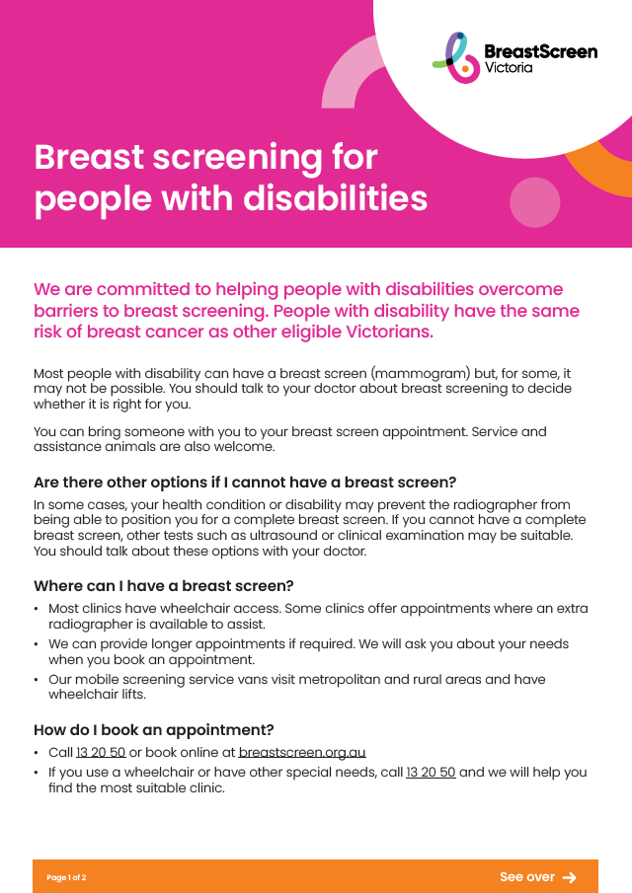 | Breast screening for people with disabilities  (A4 fact sheet)
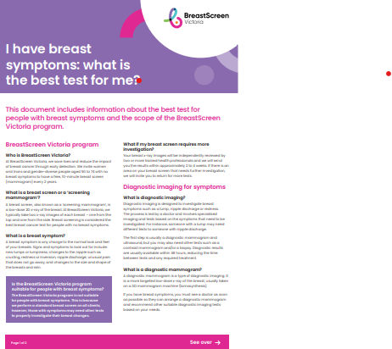 | I have breast symptoms: what is the best test for me?  (A4 fact sheet) |  | 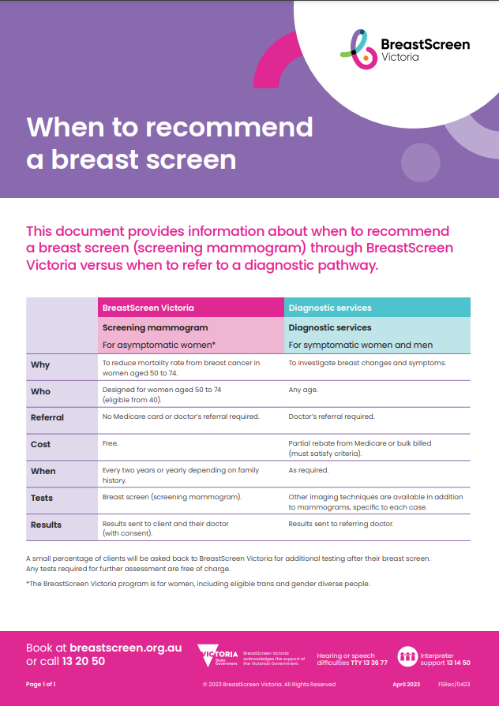 | When to recommend a breast screen  (A4 fact sheet)
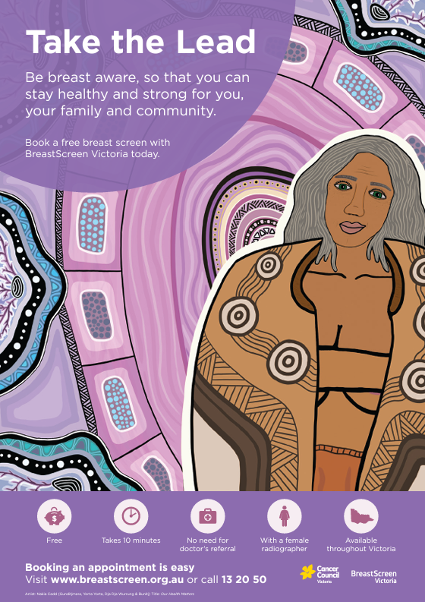 | Take the lead resources – for Aboriginal and Torres Strait Islander women |  | 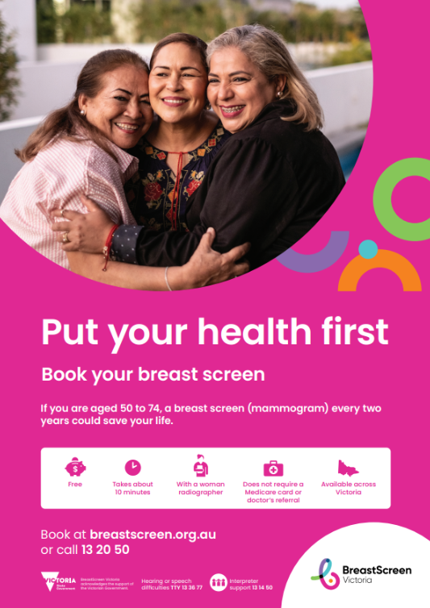 | Put your health first  A4 poster (small)  A3 poster (large)
 | DL brochure
 | Breast Cancer fact sheet (new)
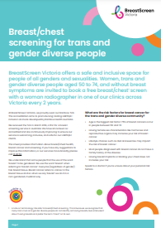 | Breast/chest screening for trans and gender diverse people
 | (A4 fact sheet)
Translated resources

Title |  |  |  | Title
  Put your health first  (DL brochure)  . |  |  |  | 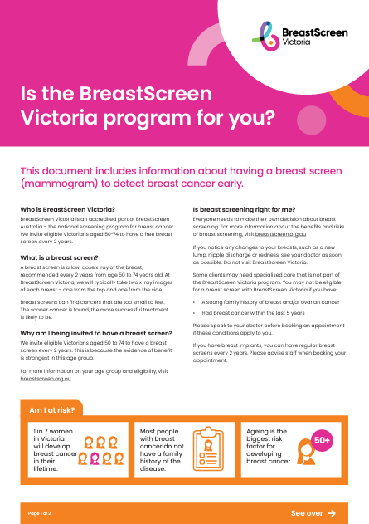  Is the BreastScreen Victoria program for you?  (A4 fact sheet)
Language | Qty | Language | Qty | Language | Qty | Language | Qty
English |  | Nepalese |  | English |  | Nepalese
Arabic |  | Oromo |  | Arabic |  | Oromo
Bosnian |  | Polish |  | Bosnian |  | Polish
Burmese |  | Punjabi |  | Burmese |  | Punjabi
Chinese simplified (Mandarin) |  | Russian |  | Chinese simplified (Mandarin) |  | Russian
Chinese traditional (Cantonese) |  | Serbian |  | Chinese traditional (Cantonese) |  | Serbian
Croatian |  | Sinhalese |  | Croatian |  | Sinhalese
Dari |  | Somali |  | Dari |  | Somali
Dinka |  | Spanish |  | Dinka |  | Spanish
Greek |  | Tagalog |  | Greek |  | Tagalog
Hindi |  | Tamil |  | Hindi |  | Tamil
Italian |  | Tigrinya |  | Italian |  | Tigrinya
Karen |  | Turkish |  | Karen |  | Turkish
Khmer |  | Vietnamese |  | Khmer |  | Vietnamese
Macedonian |  |  |  | Macedonian

